Welcome to the 64th

# Annual Denfeld Rotary Speech Tournament

**Saturday, February 1, 2025**

**Becker**

**Cambridge-Isanti**

**Centennial**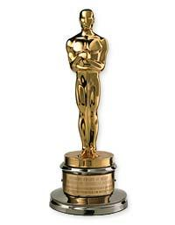

**Cherry**

**Chisago Lakes**

**Dassel-Cokato**

**Duluth Denfeld**

**Duluth East**

**Duluth Marshall**

**Forest Lake**

**Hermantown**

**Hibbing**

**Hill City**

**Hinckley-Finalyson**

**Howard Lake-Waverly-Winsted**

**International Falls**

**Irondale**

**Mounds Park Academy**

**Moundsview**

**Mountain Iron-Buhl**

**Pequot Lakes**

**Perham**

**Pine City**

**Princeton**

**Proctor**

**Rock Ridge**

**Shakopee**

**SouthRidge**

**Staples-Motley**

**Stella Maris Academy**

**St. Francis**

**Westonka**

**Walker**

**Zimmerman**